Steps and Procedure to reformat BOL document

Documents and processes required for this procedure:
- .eps file for the background layout of BOL document
- .bol script which formats and generates the BOL PDF documents
- “bolsrv” process must be running in background with “f=” argument specified with the .bol script path value
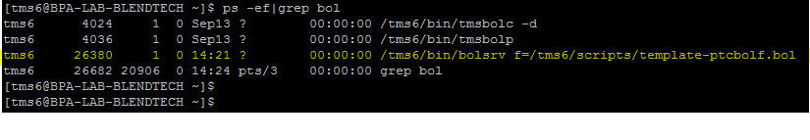
Steps

- Place the .eps file in ‘/tms6/cfg/’ directory
- Update TmsPrinter table record

psx is x-margin (left margin) for document layout
psy is y-margin (top margin) for document layout
fontsize – Fonts for BOL document text
eps – Path to the .eps file
overlay – ‘Y’ to use the layout of ‘.eps’ file
pdf – ‘Y’ to generate BOL PDF copy after each load transaction

- Update the .bol script with required “@(x,y)” co-ordinates values to fit data into layout placeholders

@(x,y) denotes the x and y co-ordinates for the text data to be placed on the document layout

Sample BOL script code:
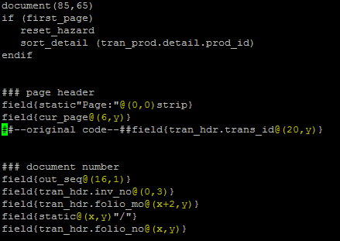

- Kill and restart currently running “bolsrv” process

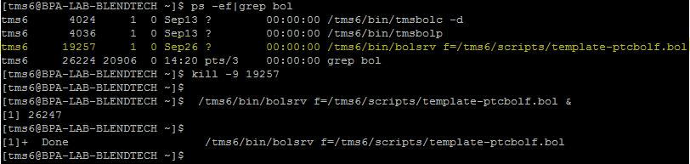

- Login as super user and restart the “cups” printer service

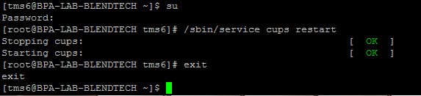

- After changing @(x,y) values , test the changes by
Performing Test load transaction from TMS Navigator client software, from Transaction -> Non Bulk Manual Transaction

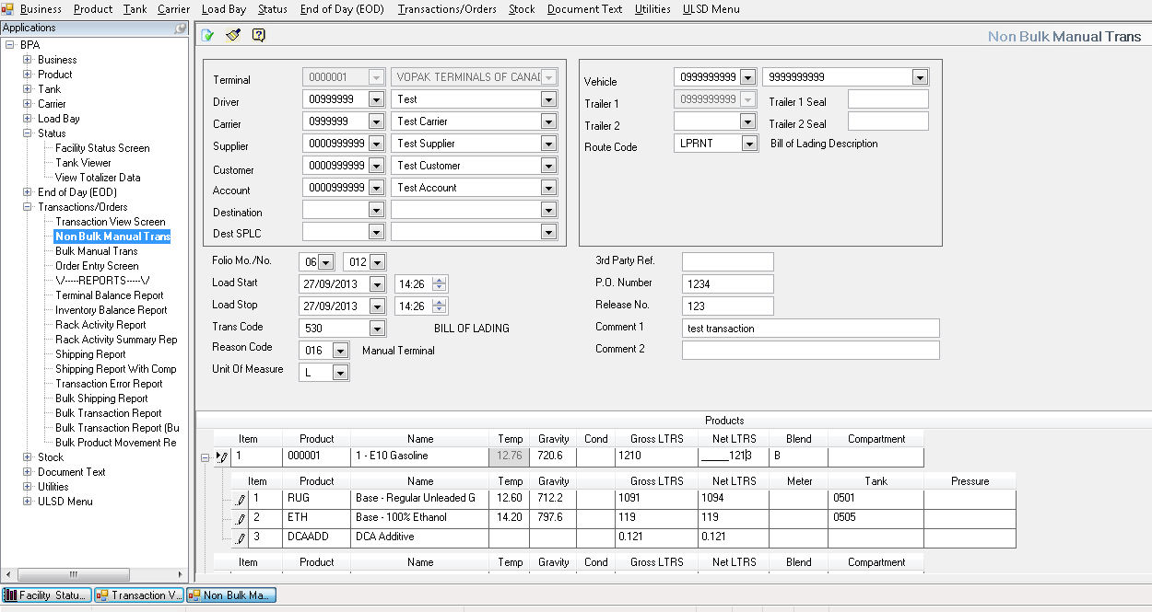

Also BOL for an existing transaction can be regenerated from “Transaction View” screen
Select and Right click the Transaction entry -> Reprint Document -> Regenerate

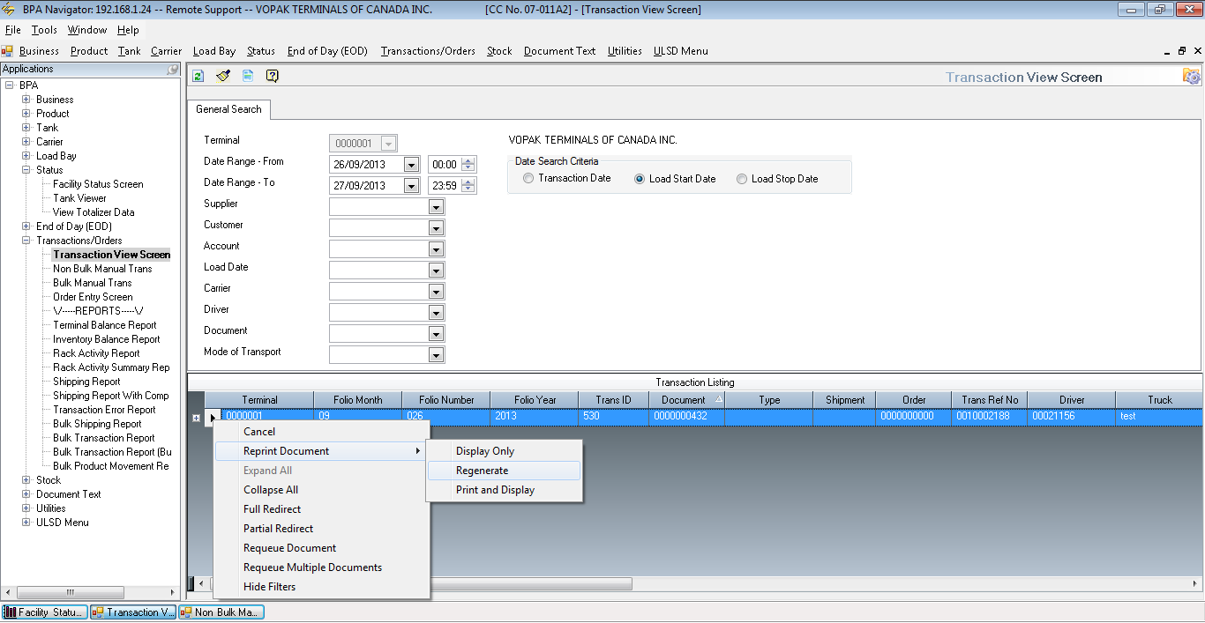

- After performing test transaction, check out the BOL PDF generated at the following path:
/tms6/docs/bol/

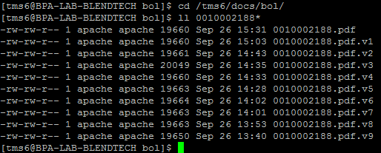

- Check whether the PDF file data are placed at proper position or not according to the changes made in @(x,y) values in .bol script

- If text positions are not proper then repeat the steps 3 to 8 until you have the data placed properly on BOL layout.

