Setting up TMS 65 VM on Mac OS:
Software Requirement: VMWare Fusion Version 6.0.6
- Copy your VM machine file (.ova or .ovf file) on Mac machine
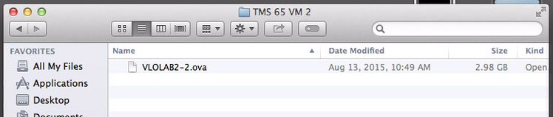

- Download VMWare OVF Tool on Mac
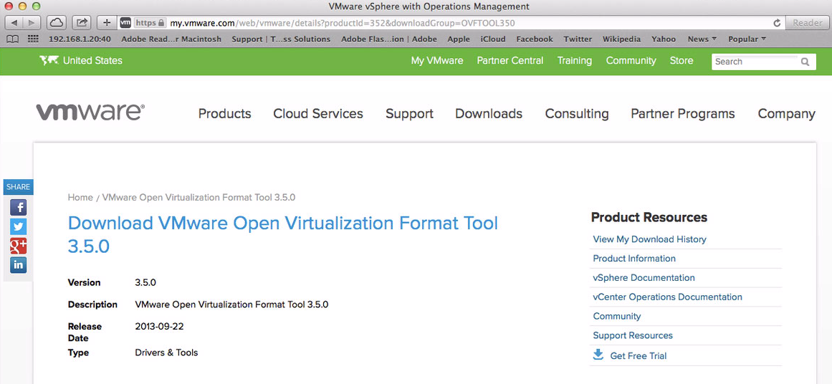
Look for Mac OSX version below to download the setup file
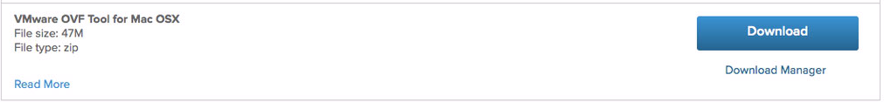

- Once download is finished, open up the appropriate “.dmg” file from Downloads folder from bottom Mac tray
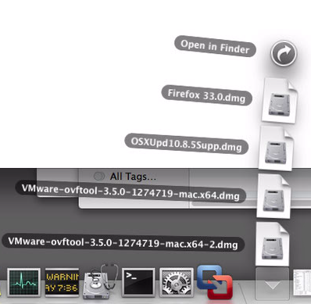

Double click on the package file shown in screenshot below
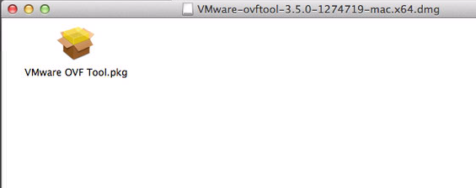

- OVF Tool installation process
Click continue
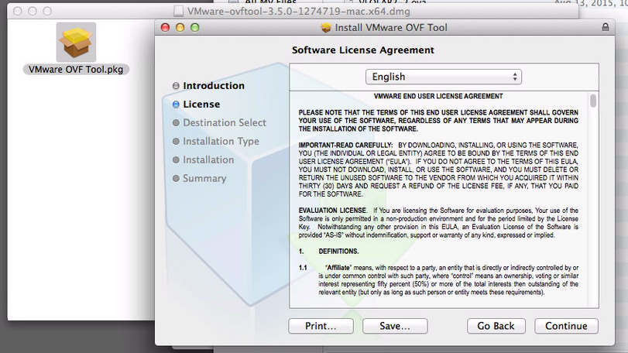

Click Agree to agree the license
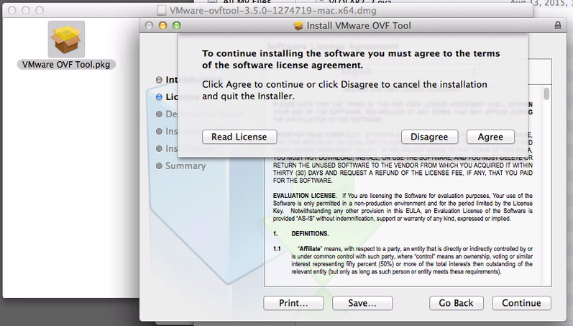
Click Install
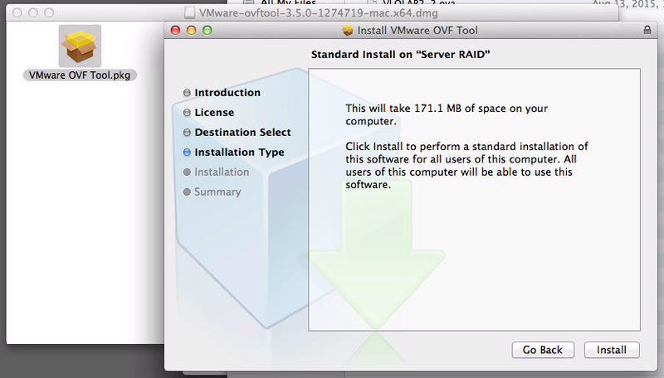

Enter your Mac machine’s username and password and click on Install Software
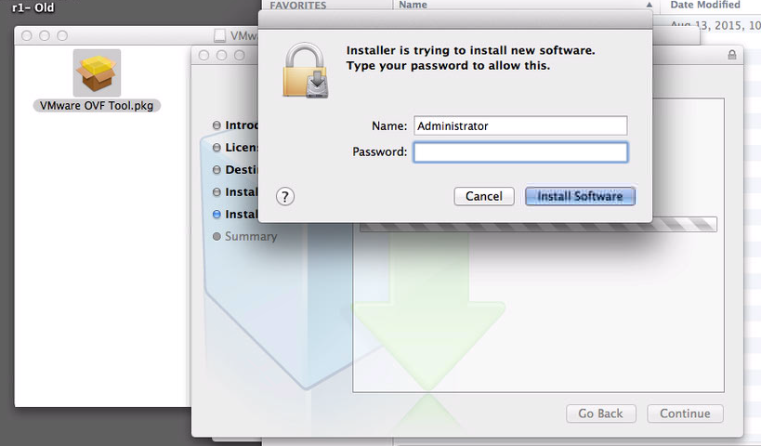

It will display screen as shown below on successful installation
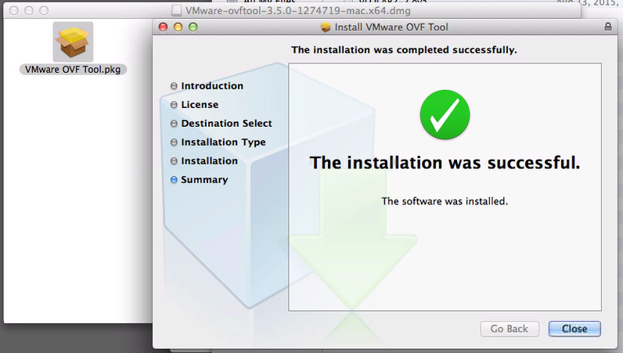

- Converting .ova file to .ovf file
Get the full directory path of .ova file on Mac (Right click Get Info Copy the “Where” file path)
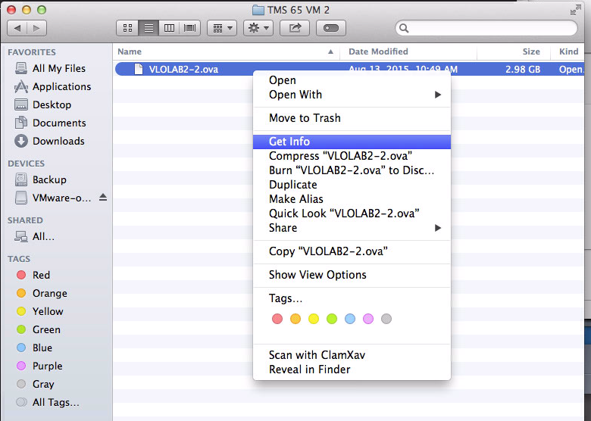
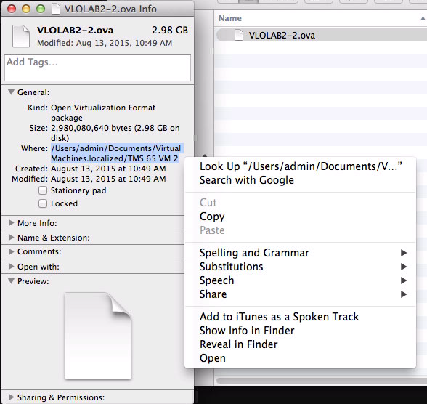
Open up Terminal console from Utilities screen
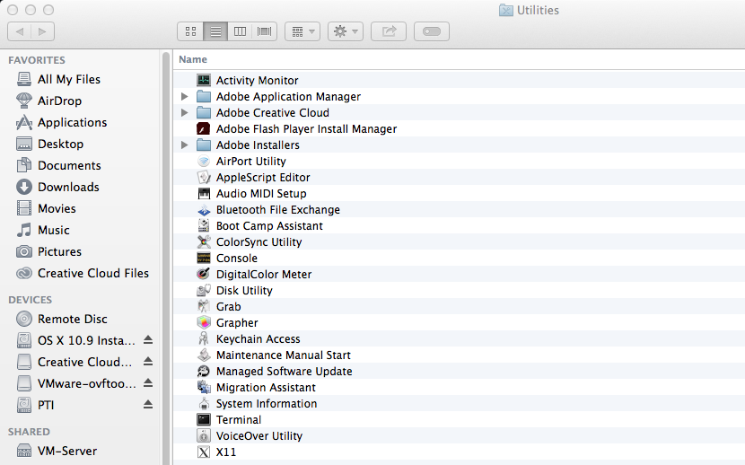
Type in following command and hit enter to convert .ova file to .ovf extension
“/Applications/VMware OVF Tool/ovftool” “<.ova file directory path>” “<directory path to save .ovf file>”
Command will look like below:
"/Applications/VMware OVF Tool/ovftool" "/Users/nupadhyay/Documents/Valero TMS65 VMs/VLOLAB2-1.ova" "/Users/nupadhyay/Documents/Valero TMS65 VMs/VLOLAB2-1-con.ovf"
Type in command and hit enter, it will start the conversion process of .ova to .ovf as shown below
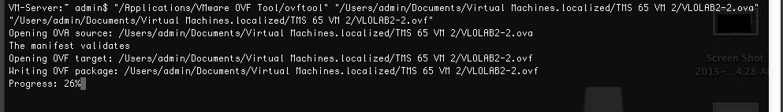
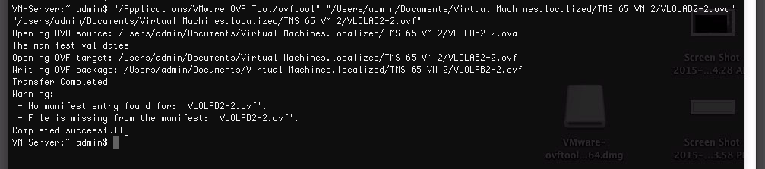
- Create VM machine by importing .ovf file

Start VMWare Fusion software on Mac
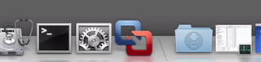

Open Virtual Machine Library from Window menu
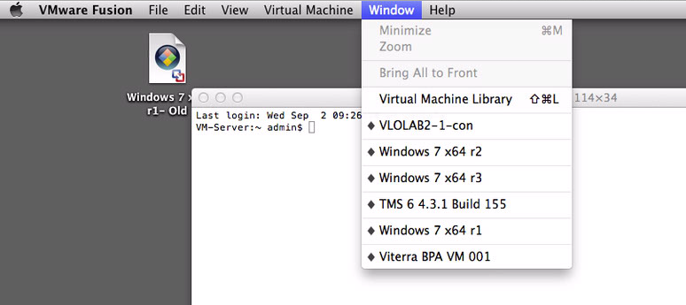

Click on “+” sign on top left corner and then click on “New” option
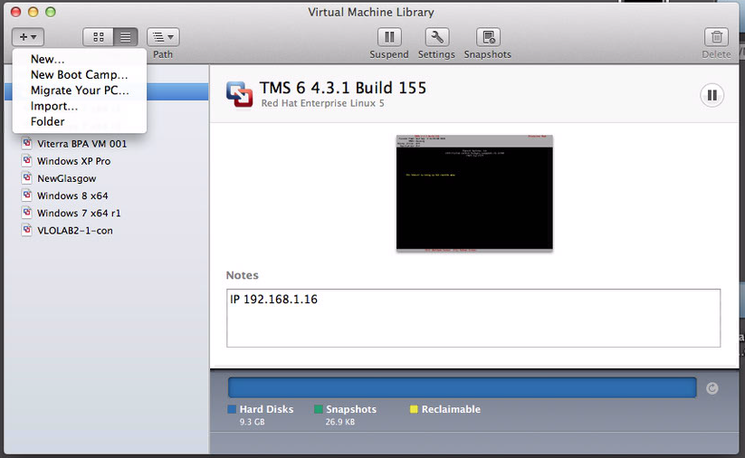

Click on “More options…” button located on bottom right
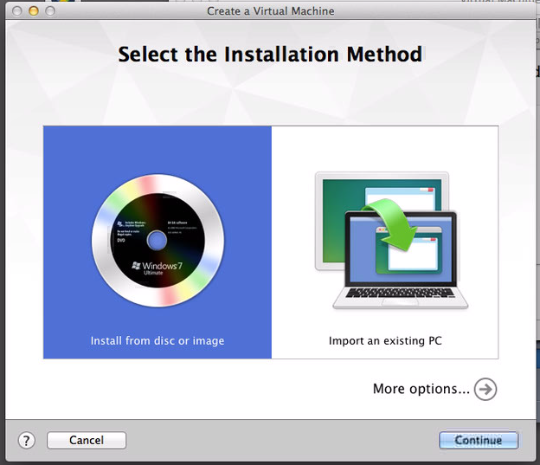

Select “Import an existing virtual machine” option and click on Continue
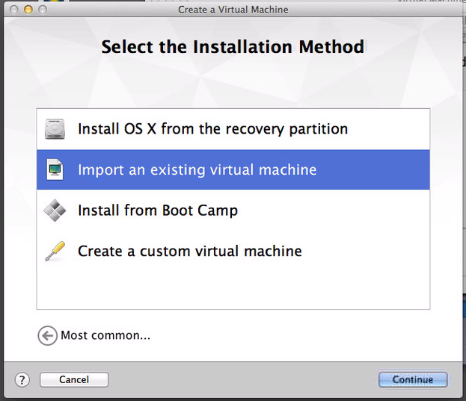

Click “Choose File” button
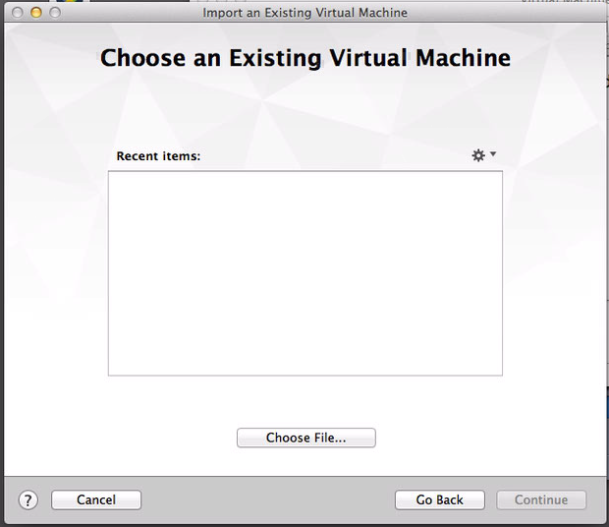
Select .ovf file we converted in step – 5
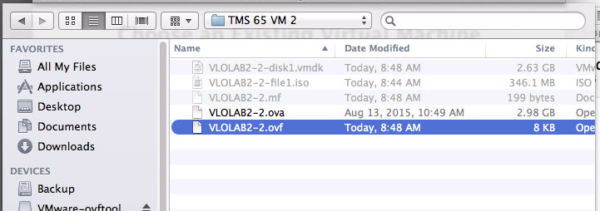

Selected ovf file will appear in Recent items section, then click on Continue
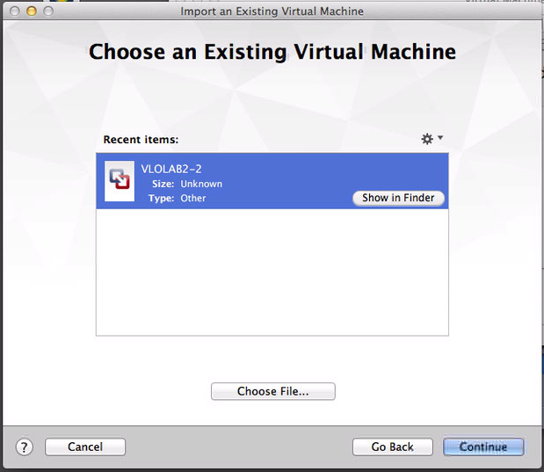

Name the Virtual Machine and specify the location where to save new VM
Then click on Save
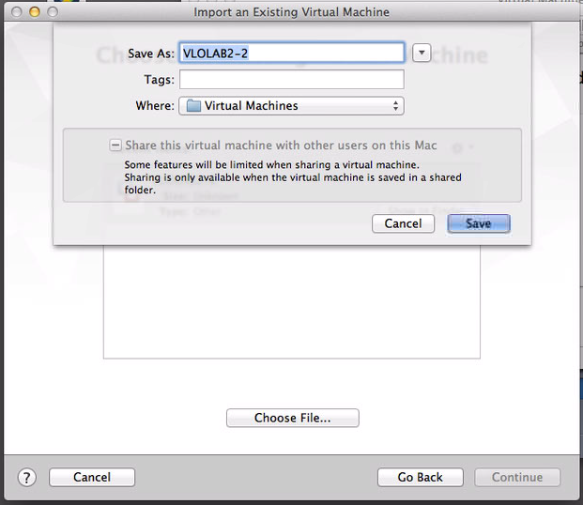

After clicking on Save, it will start importing the Virtual Machine
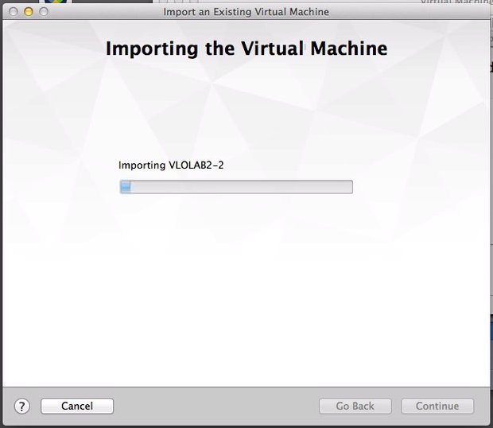

Once import progress is finished, it will display the screen below
Click Finish
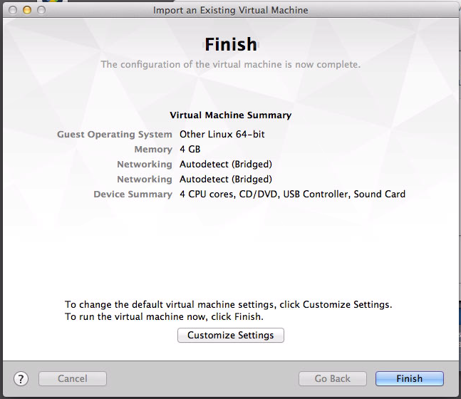

Click Upgrade to use new features supported by VMWare Fusion
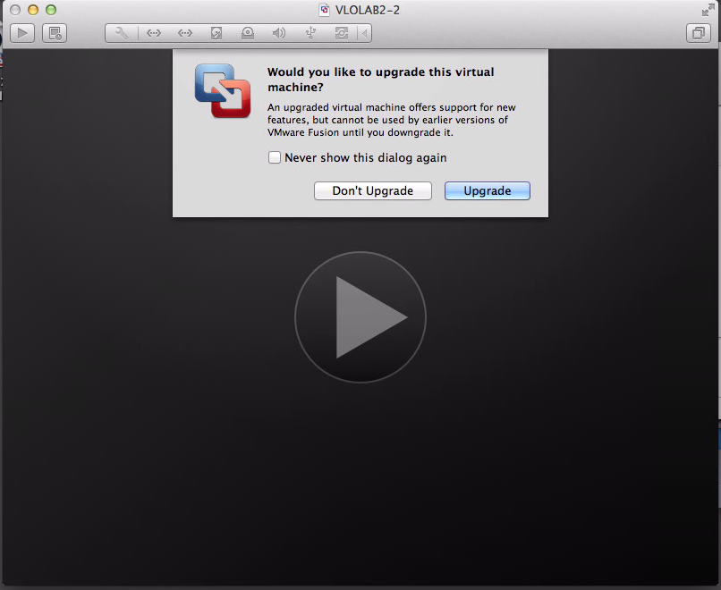

After a while it will start booting up the Virtual Machine

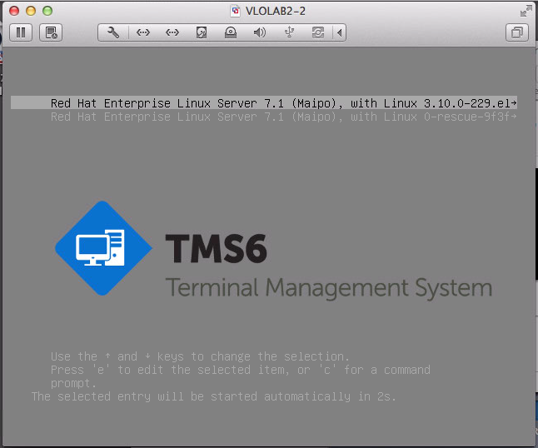

TMS 65 VM home screen

