Setting up TMS 65 VM on Windows OS:
Software Requirement: Download and Install VMWare Workstation
- Open VMWare Workstation
On Home tab click on “Open a Virtual Machine”
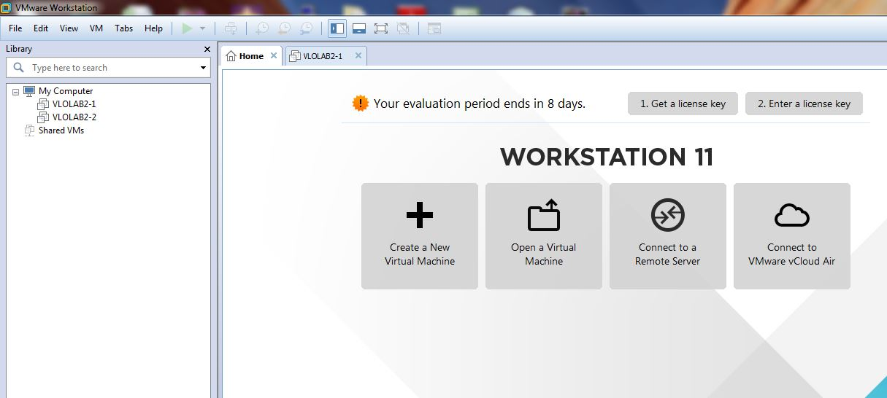

- Select the virtual machine .ova file from your computer
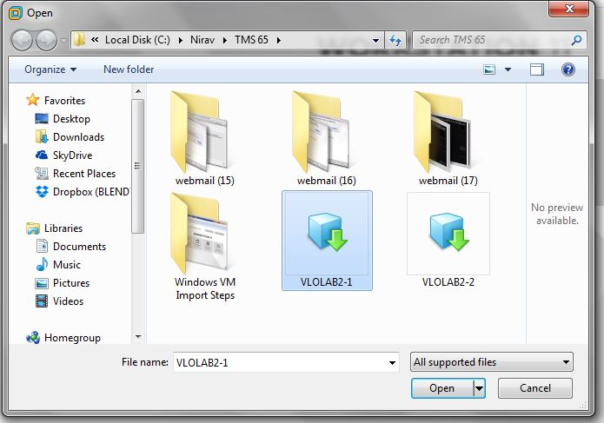

- Give a name for your VM and specify the storage path for this new VM
Then click on “Import”
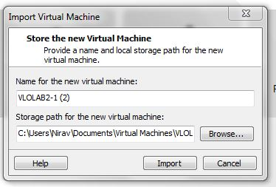

- If you see the message below, click on “Retry”

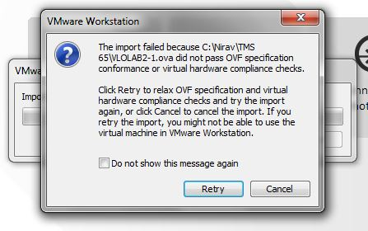

- Import process will begin, it will show progress indicator screen as below

- Once import process is finished, it will show up the new VM created on left side panel
VM details are displayed on right side window.
There are options to Power on the VM and also to Edit Settings of VM.

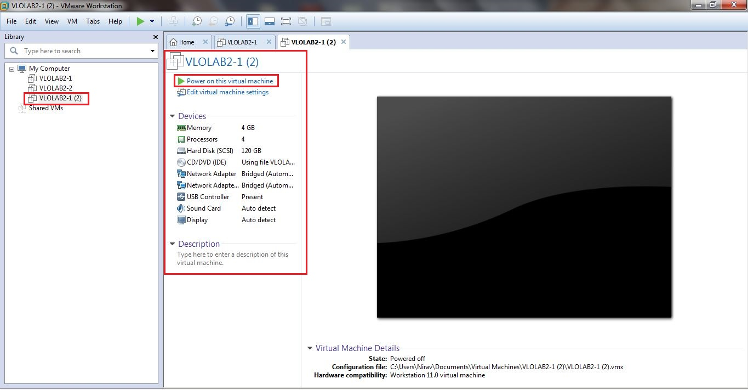

- Click on “Power on this virtual machine”
It will start booting up the VM

Click “OK” on Removable Device dialog box

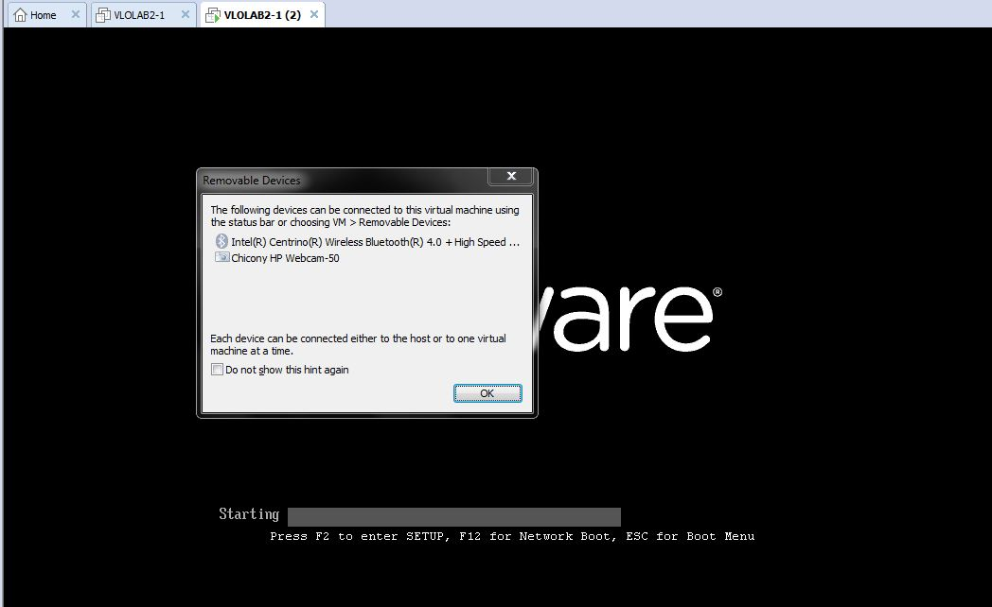

Linux RHEL 7 boot screen

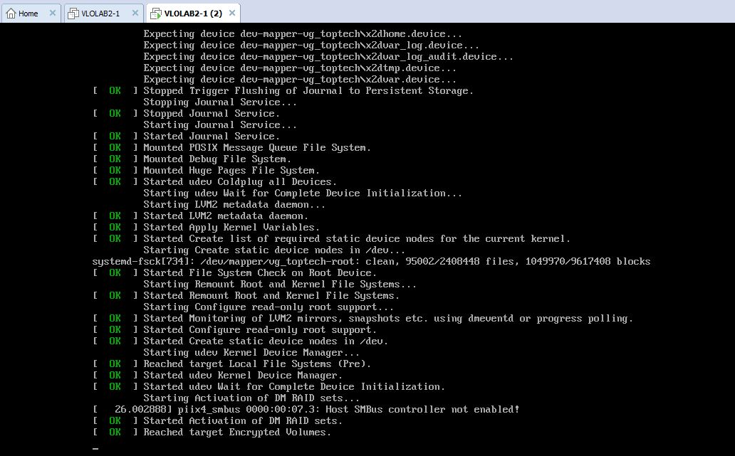

TMS 65 VM home screen

