TMS 65 VM IP Configuration:
- Start the VM and type in “ifconfig” command
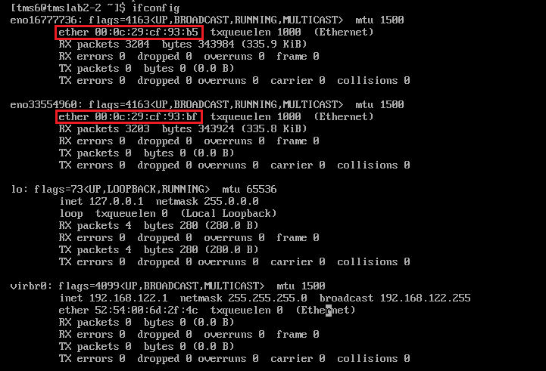
This command will output the list of network interface available on this VM that we can configure with static IP.
Note down the MAC addresses related to each network interface, highlighted in red box in screenshot above.

- Creating IP configuration files
Switch to Super User, when prompted for password enter “toptech” and hit enter.
[tms6@tmslab2-2 ~]$ su
Password:

- Change active directory to “/etc/sysconfig/network-scripts/”
[14:35][root@tmslab2-2:/home/tms6]# cd /etc/sysconfig/network-scripts/

- Create a new file “ifcfg-eno16777736È
[14:35][root@tmslab2-2:/etc/sysconfig/network-scripts]# vi ifcfg-eno16777736
Type in following content into file (values may change according to your network configuration)
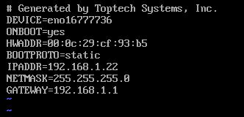
DEVICE and HWADDR value can be copied from the output of “ifconfig” command (shown in step 1 screenshot).
Make sure ONBOOT is “yes”.
Give appropriate IP address and GATEWAY address according to your local network configuration.
Save the file and exit from vi editor.

- Restart the network service:

[14:35][root@tmslab2-2:/etc/sysconfig/network-scripts]# service network restart

This command may output FAILED error message sometimes as shown below in screenshot, but still it works in terms of IP configuration. This seems like some RedHat OS related error message.

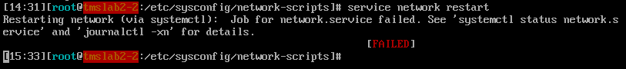

- Type in “ifconfig” command to check if new IP has been successfully assigned or not

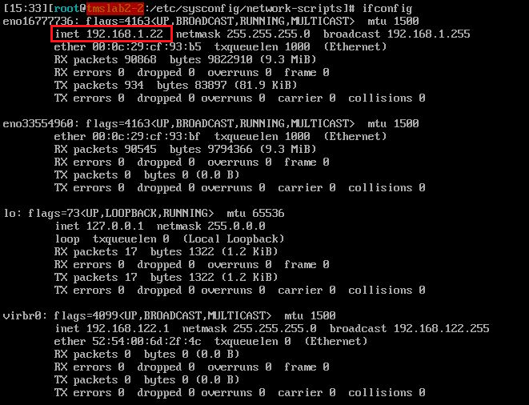

Verify at the end that ifconfig command outputs the IP address you configured in “ifcfg-eno16777736” file in Step-4.
As highlighted in red box, this machine has been assigned IP address 192.168.1.22.
Few settings to be checked on VMWare and Windows OS:
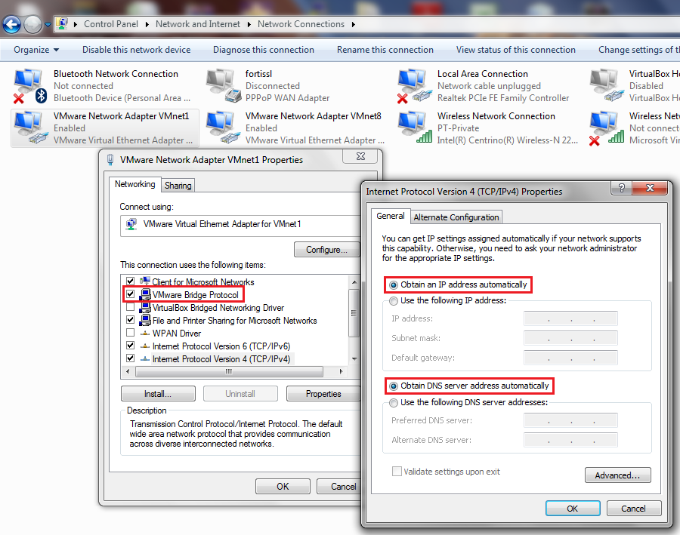

VMWare Machine Setting:
