TMS6 – LINE COMMUNICATION “LC” CONFIGURATION AND PROTOCALS

The Line Controller “LC” is the standard way that Toptech handles communications with other compatible devices “Multiload, Accuload, etc”.
A standard Line Controller “LC” will have the following flags.

n=server name -- the name to attach to this lc
m=serial_port -- the serial port used for the lc - If tcpip, this is the port number
[tcpaddr=] --address of device that we will connect through ip
[t=*] -- timeout value in msec defaut (500)

eg.

/tms6/bin/lc n=RACK1 m=7734 tcpaddr=10.10.10.10 t=3000

Below is where you configuring the Bay Profile with a Line Controller name. For the purpose of this example the LC name is RACK1:

Under the Facility Configuration menu choose Bay Profile. Then go to the RCU Controller tab and navigate to the Line Control Name. This is where you will identify the n= parameter that was used on the LC “RACK1”.

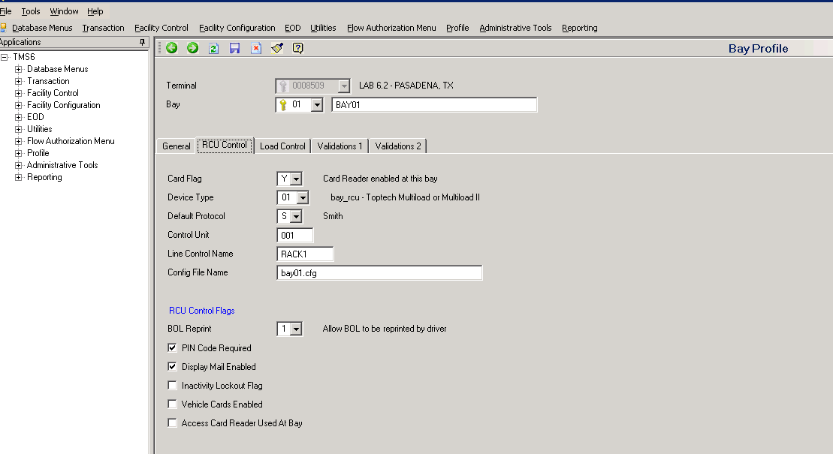
Line Control Name

Both the n= parameter on the LC and the Line Control Name can be whatever name you want to give it, but they both have to be the same. However, typically we give them names to describe their purpose. For example, if we are communicating with BAY01 we name the Line Controller “LC” RACK1 and the Line Control Name on the Bay Profile would also have to be named RACK1.

The Preset Profile also has to be configured with the Line Control Name “Control Name”:

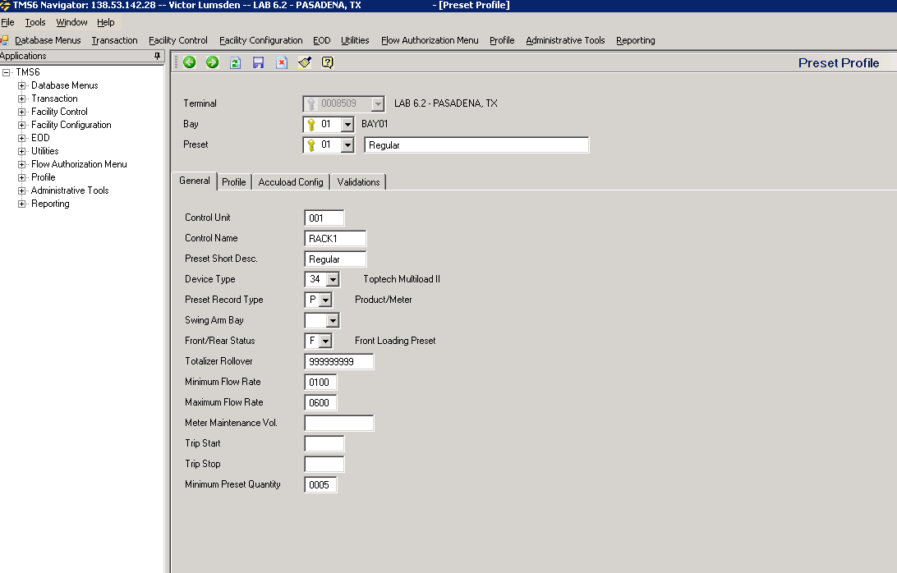
Control Name

The Meter Profile also has to be configured:
“Control Name”
Enter the name posted by the line controller task that handles the communication link between TMS6 and the preset. If the preset is a mechanical preset, this field is unused.

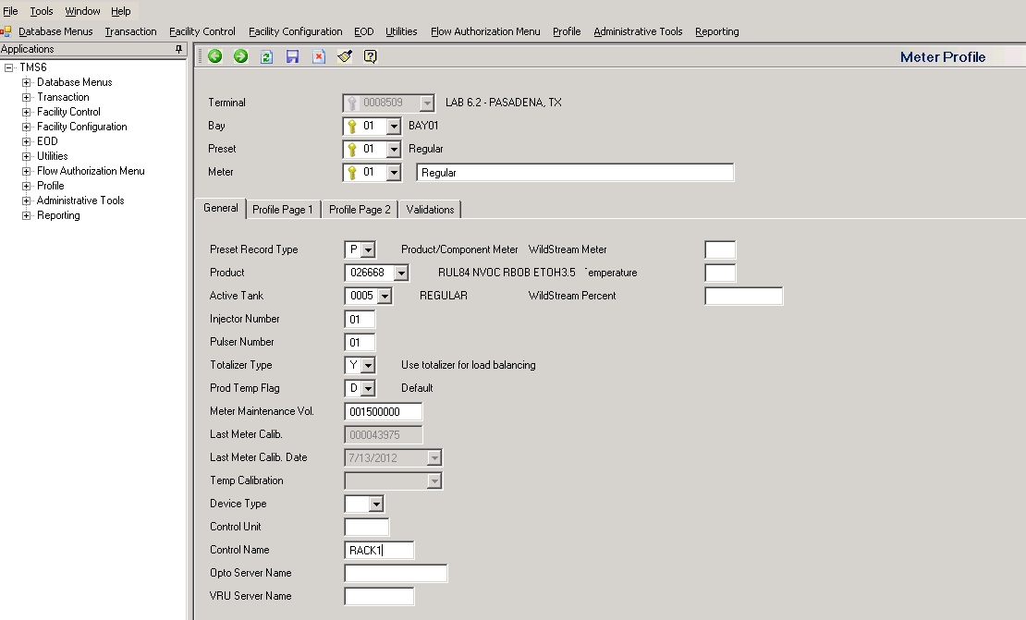
Control Name

The Line Controller is an important part of the communication process. Without the line controller running, the Bay, Preset, Meter will not start.

NOTE:

If you see errors in the Log stating COMMUNICATION FAILURE, one of the first things to check is to see if the LC is running for the bay that is reporting the error. Then check the BAY, PRESET, and METER profiles to confirm that they are configured correctly. Also, be sure to check the configuration in the preset “Multiload, RCU, etc” to confirm proper LC configuration.

Below are all the flags that are available for use on the Line Controller “LC”:

[tms6@TMSLAB-1 ~]$ use lc|less

File reading from /toptech_prj/bin/lc

lc - toptech line controller Ver 2.0

Useage: lc m=serial_port n=server_name [options] &

m=serial_port -- the serial port used for the lc
If tcpip, this is the port number
n=server name -- the name to attach to this lc

Where: [options] are

[t=*] * -- timeout value in msec defaut (500)
[it=*] * -- initial timeout value in msec default (500) [MODBUS ONLY]
[p=*] * -- set the priority level
[pad=*] * -- number of pad characters default (1)
(Smith / Titan) and EM4 (Contrec set to 0)
[delay=*] * -- number of milliseconds to delay prior to send (0)
[r=*] * -- number of retries after timeout default (5)
[+t] ---- trace messages to stdout
can be toggled from lccomm by typing 'trace'
[+v] ---- verbose log messages to logger (disk only)
can be toggled from lccomm by typing 'verbose'
[+c] ---- comm trace
[+bj] Contrec only BJ Application Pack
[+r] ---- log response time for each messsage received
[lp=*] * -- log poll interval (default 1 hour, see +ls & +la)
[+ls] ---- log comm statistics each log poll interval
(average of ALL devices on this lc)
can be toggled from lccomm by typing 'logstat'
Data will print to the disk event log.
[+la] ---- log comm statistics each log poll interval
(average of EACH device on this lc, by address)
can be toggled from lccomm by typing 'logaddr'
Data will print to the disk event log.
[+o] change opto end character to a CR instead of '.'
[+s] ---- simulate preset (currently weighscale)
Simulate Mode ignores the m= parameter by not opening
the device. To change the current weight on the
weighscale, send a SET=value via tmslcomm.
To simulate loading over a weighscale first send a
SET=value via tmslcomm. Then send a FLOW=value for
the flow rate in minutes. To start flowing send a
MAX=value for the value to stop at (the simulator
will not always stop at the value, but may go over).
Sending a SET=value resets the flow rate and stop points
to zero.
[+nst] no start text character offset is from et char message
is read using length of data
[st=] st=Start of text character for weighscale packet.
Default st=2
[et=] et=End of text character for weighscale packet.
Default et=13
[wo=] wo=start of gross weight field for weighscale data
Example packet:
STX D1 D2 SP GGGGGG SP CR
0 1 2 3 456789 10 11
Then wo=4, default wo=4
[wl=] wl=length of gross weight field for weighscale data
Example packet:
STX D1 D2 SP GGGGGG SP CR
0 1 2 3 456789 10 11
Then wl=6, default wl=6
[wslm=] Overall length of weigh scale message (number of chars)
to read from the serial port. (used with no real et=)
Default wslm=100
[mpos=] Position in weighscale packet to look for the Scale In
Motion indications (ascii 'M'). If this parameter is
not provided the indication is not looked for.
[wsto=] Weigh scale timer for polling the scale serial port
Timer is in tenths of a second. ex wsto=6 : .6 seconds
Default wsto=0 (not used)
With FCMs default/max = 40 (4 seconds)
[wsto1=] Time (in tenths of a second) before a comm error
is reported by setting the 'Vapor Disconnect' bit.
Default is wsto1=0 which disables the error report.
The bay= parameter must be specified when wsto1= is
specified.
[wsto2=] Time (in tenths of a second) before the bay associated
with this scale is disabled.
Default is wsto2=0 which disables the action.
The bay= parameter must be specified when wsto2= is
specified.
[bay=] The logical name of the bay associated with this scale.
If not provided the scale comm error and scale in
motion detection features are disabled.
[-skipflush] For Contrec Additive Injectors (use EM4 Protocol)
enable skip flush of input after send request
[ts] enable TITAN SPACE character before message.
May be needed when OLD and NEW titans are on the same
line.
[tcpaddr=] address of device that we will connect through ip
[tcpto=] tcp ip timer to flush chars on com port.
(default 2 min)
[+fcm] This lc is used for FCMS only. Use wsto= param
to set the FCM watchdog timer reset value. When +fcm
is specified the min value for wsto=10 and the max value
for wsto=40 default for wsto= when +fcm is specified is
40. To get the time which this represents take
(wsto value * 100) / 1000 = total seconds which will elapse
before weight timer will expire.
[fcmexpr=] FCM max. timer expiration count. This value determines
rate at which ALL the FCMs will be polled to determine
if any new FCMs have been added to the system. This
value is just a count of the number times the weigh timer
must expire before "pinging" all FCMs for status. This
is used to reconfigure into the system any FCMs that have
been added or repaired without having to restart the LC.
Default is 40. So the length of time this represents is
determined by ((weigh_timer value * 100) *
(FCM max. timer expiration count)) / 1000 = total seconds.
[+evt] especially verbose trace messaging
[+3964] connected to Siemens S7 using 3964R protocol
[+mfx90] connected to MFX 90 uses wsto timer as polling
interval defaults to wsto=5
[+mfx100] connected to Sercon/MFX 100 uses wsto timer as polling
interval defaults to wsto=5
[-cnvt] do not convert lbs to kgs automatically
[+restart] When doing ip interface, do restart instead of closing
the socket handle to re-connect. Use at term server
sites where comm is bad to termserver.
[reset=] MFX90: delay in seconds for sending the current
message if the last message send was a "RES"
VIP: delay in seconds after a "reset" is sent to the VIP
[+dan] MFX90 only: Send a "DAN" message instead of a "RES" on
unit startup to retrieve totalizers. Otherwise "DAT"
responses are ignored.
[-crc] For use with Modbus Protocol - remove CRC check
[-iac] Remove second IAC (0xFF) in data streams (Modbus Protocol)
[+rebootok] responds to a reboot command with success, if timeout. (Smith Protocol)
[+mfxdye] MFX90 only: forces the default of the LAD telegram for
additive type to "00" instead of "10"
[+utf8] Convert to UTF8 format
[twic=] Twic Server Name for use with TWIC cards

