BLENDTECH
TMS6 Load Rack Communication Testing
Testing 4 – wire 485 loopback and ping over IP from TMS6
Joshua Edelman
12-29-2014

Table of Contents

1 | Overview | Pg. 2
2 | Accessing Tools | Pg. 2
 | Interface Application (Putty) | Pg. 3
 | From the TMS6 server | Pg. 4
3 | Establish Line Communication | Pg. 5
 | RCUII/ Multiload | Pg. 5
 | Other Devices | Pg. 5
 | Establish Line Controller | Pg. 5
4 | 4 – Wire 485 Loopback Testing | Pg. 7
 | Using Lccom | Pg. 7
 | Serial Testing Procedure | Pg. 8
 | Communicating to Field Device | Pg. 9
 | Protocol Options | Pg. 10
5 | Ping Testing | Pg. 11

TMS6 Load Rack Communications Testing

1 - Overview
The purpose of this document is to assist a BLENDTECH technician in establishing and validating communications to field devices.

There are two main protocols for transmitting information between devices. There are two methods used to validate communications between devices, one for each protocol.

Communications Protocol | Validation Method
Serial | Loopback
IP/ Ethernet | Ping

There are three versions of Serial Communication protocol, only one of which allows for loopback testing.

Serial Protocol | Validation method
2- wire 232 | None
2 - wire 485 | None
4 - wire 485 | Loopback

2 - Accessing Testing Tools
Blendtech technicians can access the tools necessary for communications testing two ways.
- Interface Application (Putty)
- From the TMS 6 server

Interface Application (Putty)
A terminal interface application may be used to access the Loopback and Ping testing software. BLENDTECH typically uses a program called Putty to interface to the TMS6 server over IP port 22.
Prerequisites:
- BLENDTECH technician must have access to the TMS6 server over IP
- Customer network must allow communications via port 22.

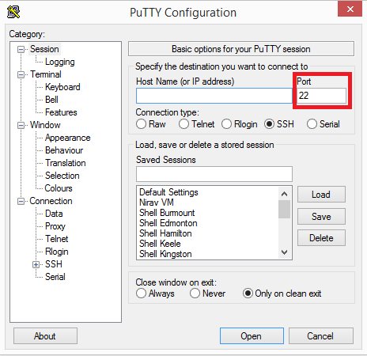
Putty can be downloaded from the internet at any of the links at this location:
http://www.chiark.greenend.org.uk/~sgtatham/putty/download.html

It is also available on BLENDTECH’s drop box at this location:
https://www.dropbox.com/home/Toptech%20Reference%20Center/Tools

Once the putty application is moved to the customer’s client computer, enter the TMS6 servers IP address and click ‘Open.’
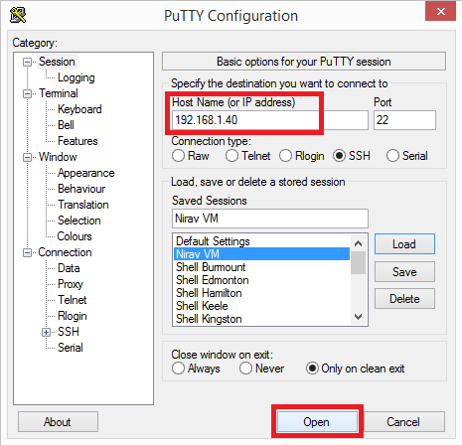

This will allow the tech to access the linux operating system via a login screen. Login is CASE SENSITIVE.
Login as: tms6
Password: toptech

From the TMS6 Server
Addressing the TMS6 server’s monitor, the BLENDTECH technician will see this screen.
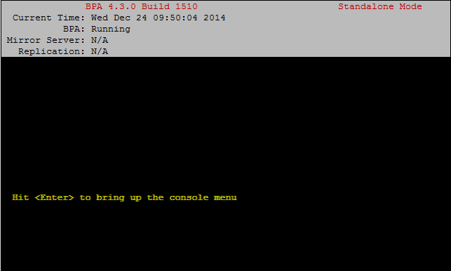

Hold ALT + F5 to switch to console 5, which will allow the tech to access the linux operating system via a login screen. Login is CASE SENSITIVE.
Login as: tms6
Password: toptech

3 - Establish Line Communication
RCU/ MULTILOAD
The communication program and parameters used by TMS6 will be listed in the Bay Profile screen for any of the following devices:
- RCU I or II
- Mutliload I or II

The name of the program and parameters used are found on the Bay Profile screen, under the RCU Control tab.
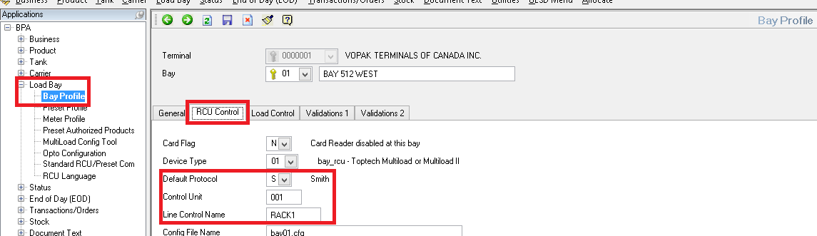

Other Devices
The name of the program and parameters used to communicate with Acculoads and all other devices are found on the Preset Profile screen under the General Tab.
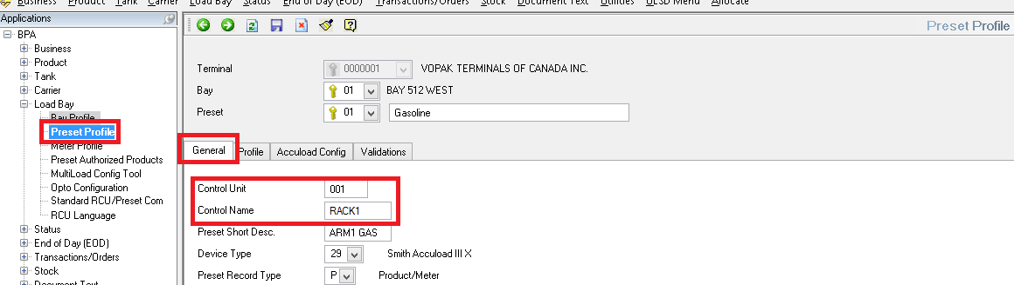

Establish Line Control
From Putty or from the linux client at the TMS6 server, the tech can then verify that this program is running using the following command:
ps –ef|grep <Control Name>

In this instance the Control Name RACK1 from the images above is searched for using this command. The Line Control, or lc, program /tms6/bin/lc is returned with the ‘n=’ parameter indicating the name RACK1.
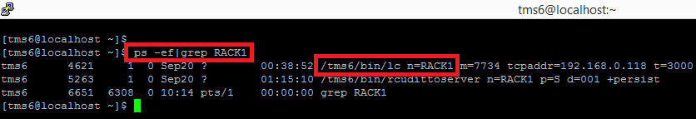
If nothing is returned:
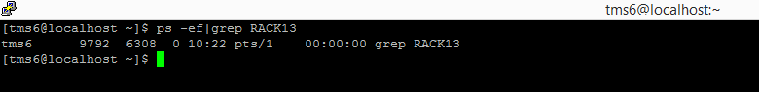

If no lc program is returned, the tech can start the lc program by manually executing the command.
- At the $ prompt, type: cat /tms6/scripts/start.lc.sh
- Using the mouse, highlight the resulting line that contains the ‘n=’ parameter name in question.
- Right click the mouse to paste the lc command at the next $ prompt (bottom).
- Ensure that the lc command ends with ‘&’ character.
- Hit enter.
- Verify the lc program started using the command: ps –ef|grep <ControlName>
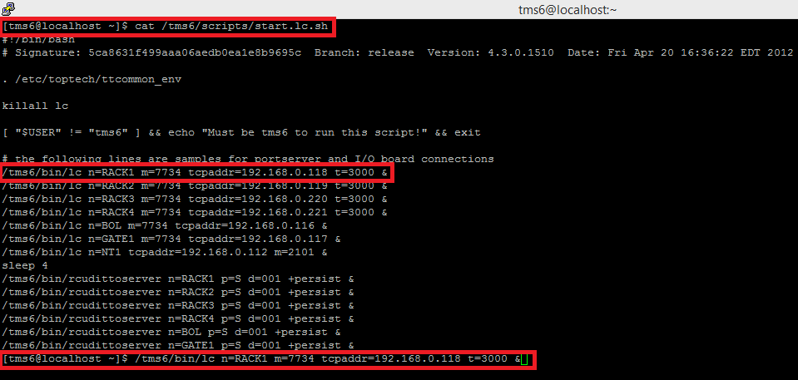

4 - 4 wire 485 Loopback Testing

Using lccom
Once the lc program has been verified running, the lccom program will send data through the lc program to the address specified on the Bay Profile or Preset Profile screen for the device in question.

To launch the lccomm program type the following
lccomm n=<ControlName> d=<Device Address> +J

Using our example from above:
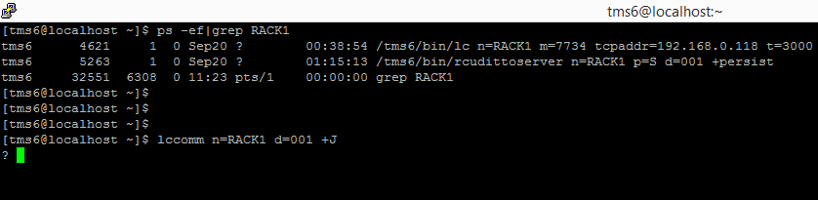

In a closed loop, or loopback, any info typed at the ‘?’ prompt will be returned and duplicated on the screen after the tech hits ‘Enter.’ All connections can be identified as good between the TMS6 server and the point in the serial line where loopback can be made.

If the circuit is broken at any point on the serial line, an error may be returned or nothing at all and the program may hang after the tech hits ‘Enter.’

At any point in the serial line where loopback cannot be made, connections, wiring, and devices should be inspected for continuity between the point at which the error occurred and the point of last successful loopback.

Serial Testing Procedure
Once the Line Controller has been established, use the lccomm program to test for loopback at each of the following locations on the 4 - wire 485 serial line:
- At the field device
  - Jumper TDA to RDA, as well as TDB to RDB (twist together or jumper terminal block)
  - Test loopback using lccomm.
  - Remove field device jumpers.
- On the field side of the Optical Isolator
  - Jumper TDA to RDA, and then TDB to RDB.
  - Test loopback using lccomm.
  - Remove the field side Optical Isolator jumpers
- If the serial line utilizes a serial port expander with field side 485 protocol or a Digi TS 16 device,
  - Remove the serial cable from the computer/ house side of the Optical Isolator
  - Connect or jumper pin in position 2 to pin in position 3
    - Facing the serial connector with the long row on top, positions begin at 1 starting at the top left of the longer, top row and positions may or may not contain pins.
  - Some Digi devices contain loopback jumpers that can be inserted into the Digi Port instead of performing the previous step (b. above).
  - Once the pins in positions 2 and 3 are connected (b. above) or the loopback jumper is inserted into the Digi (c. above) then test loopback using lccomm.

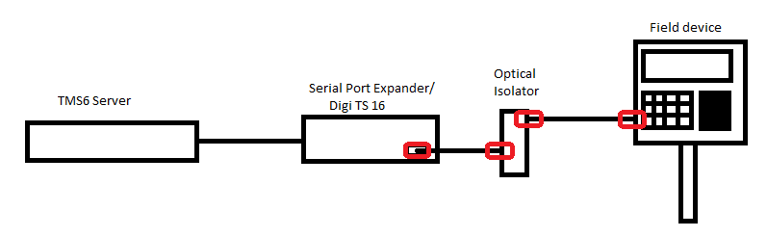

Communicating to field device
Once loopback has been verified all the way to the device, remove the jumpers and use lccomm to communicate to the field device.

In the case of RCUs and Mutliloads, use the +S flag in place of the +J flag to utilize the Smith Communications protocol. Under this protocol, the R character indicates a read procedure followed by the register you wish to read. For all Toptech devices, register 000 (command: R000) will return the firmware version of the device.
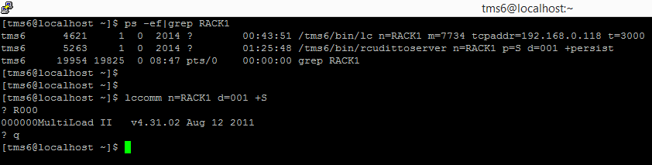

Using lccomm you can pretty much test most devices connected to Toptech. We also use this to test MODBUS (+4) to a PLC or tank gauge, communications to an Accuload (+S) or OPTO22 B1 (+O) Brain Board for example. Basically lccomm provides an open serial port for testing - keeping in mind lccomm will add the wrapper <STX><ADDR><message><LRC><ETX>. You’re only entering the “message” part.

Protocol options
[+A] -- Titan
[+T] -- OTC
[+S] -- Smith
[+B] -- Brooks
[+O] -- Opto22
[+D] -- Daniel (Requires HEX input. For ASCII input, use danlcomm)
[+F] -- Fingerprint reader
[+E] -- EM4
[+C] -- Contrec 1010
[+P] -- Contrec 1020
[+G] -- FB9201 Weigh Scale
[+H] -- AN5316 Weigh Scale
[+W] -- Weigh scale
[+I] -- Weigh scale (Generic)
[+J] -- LOOP BACK
[+K] -- AB PLC for RCU
[+L] -- Vip Scully Trailer id (Requires HEX input. For ASCII input, use scully)
[+M] -- Smartpass Amtek Trailer id
[+N] -- Waugh
[+Q] -- Ortech
[+R] -- Elvis
[+U] -- Waugh2300
[+V] -- Civacon Trailer Id
[+X] -- Vega
[+Y] -- FCM
[+Z] -- MFX
[+1] -- Shenck WeighBridge
[+2] -- Shauf Marquee
[+3] -- 3964R
[+4] -- Modbus
[+5] -- Precia Molen I200/b
[+6] -- SLC500
[+7] -- ITM
[+8] -- MCG3401
[+9] -- Hardi
[+0] -- Alpha Sign Marquis
[+a] -- Nedap Trailer Id
[+b] -- Enraf 854 Tank Gauging
[+c] -- Sampi
[+d] -- Smart One
[+e] -- PLC5
[+f] -- MCGMTU77 Tank Gauging
[+g] -- SNPX GE Fanuc 90/30 PLC

5 - Ping Testing

If the field devices are connected to TMS via IP, the IP address will be displayed in the line controller as the tspaddr= parameter.
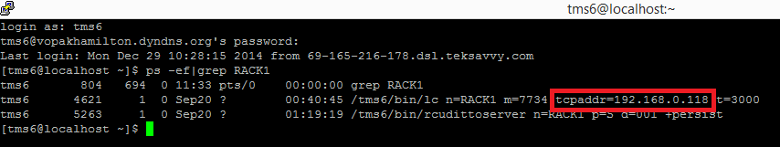

Use the ‘ping’ command to determine if packet data can be routed to the address of the field device. Ensure that the correct IP address is configured into the field device first.
ping <IP Address>
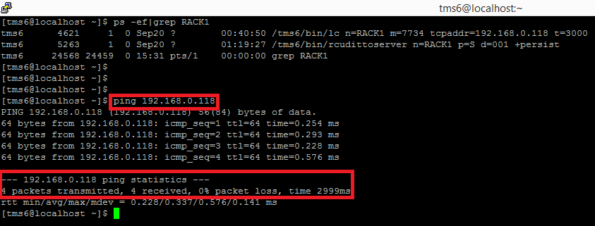

If 0 packets are transmitted or there is any packet loss, ensure that the default Gateway Router can be reached via ping.

- Ensure the field device has the correct IP, Gateway, and Netmask programmed.
- Ping the IP of the field device.
- If there is packet loss, ping the Gateway Router.
- If there is packet loss to the Gateway, inform Customer’s network specialist.
